**Introduction to internet**

**Basics**

**LAB: 06**



**Fall-21**

[**CSE-102L Computer Fundamental Lab**](https://classroom.google.com/u/2/c/MzA5OTAwMDgwMjI2)

Submitted by: **Amir Suliman**

Registration No: **19PWCSE1805**

Class Section: **B**

“On my honor, as student of University of Engineering and Technology, I have neither given nor received unauthorized assistance on this academic work.”

Student Signature: ______________

Submitted to:

**Engr. Abdullah Hamid**

March 19, 2022

Department of Computer Systems Engineering

University of Engineering and Technology, Peshawar

**Objectives:**

* Know about Wi-Fi router
* How to access Wi-Fi router admin panel
* How to send an attachment file in email

**Lab Task:**

**- Explain how you will access a Wi-Fi router admin panel attach screenshots of each step.**

Following are the steps required to access the Wi-Fi router admin panel.

**Step1:**

Search Command Prompt in the search bar and press enter or click open to open the app.

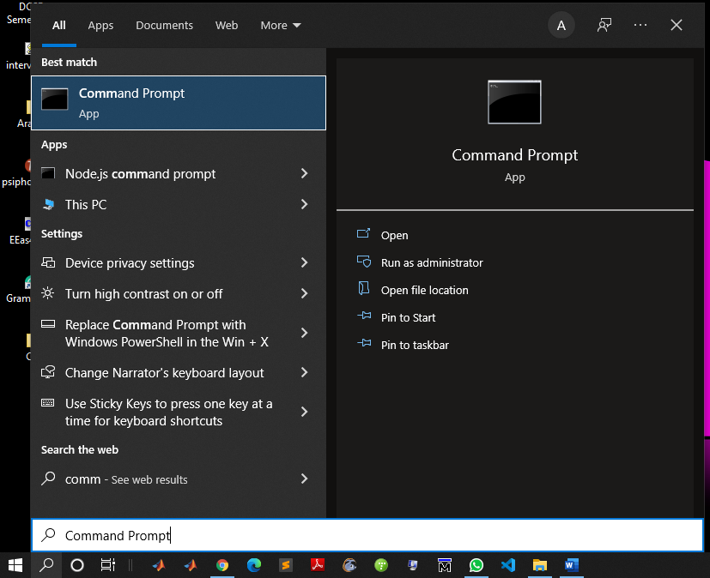

In Windows 10, you can also go to **Settings > Network & Internet > Status > View hardware and connection properties**.

**Step2:**

After opening the command prompt, type ‘ipconfig’ to know our IP address in ord

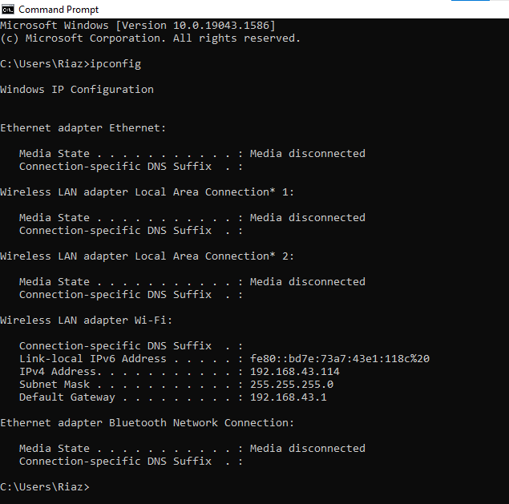



**Step3:**

Copy your Default gateway and paste it into your browser. Then enter your username and password to login.

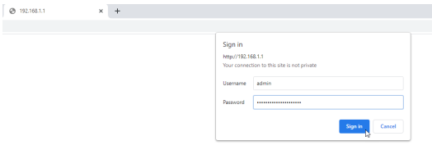

**Step4:**

As you longed in your Wi-Fi router panel will be opened. Admin panel include many options, you can change any option you want.

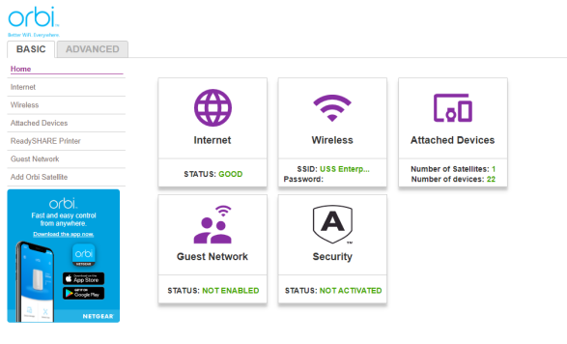

**Explain how you will send an email with an attachment that has a size more than 30mb,**

**explain each step and attach screenshots for each step in the lab report.**

The following are the steps required to send an attachment of size more than 30mb using gmail.

**Step1:**

Open your gmail.

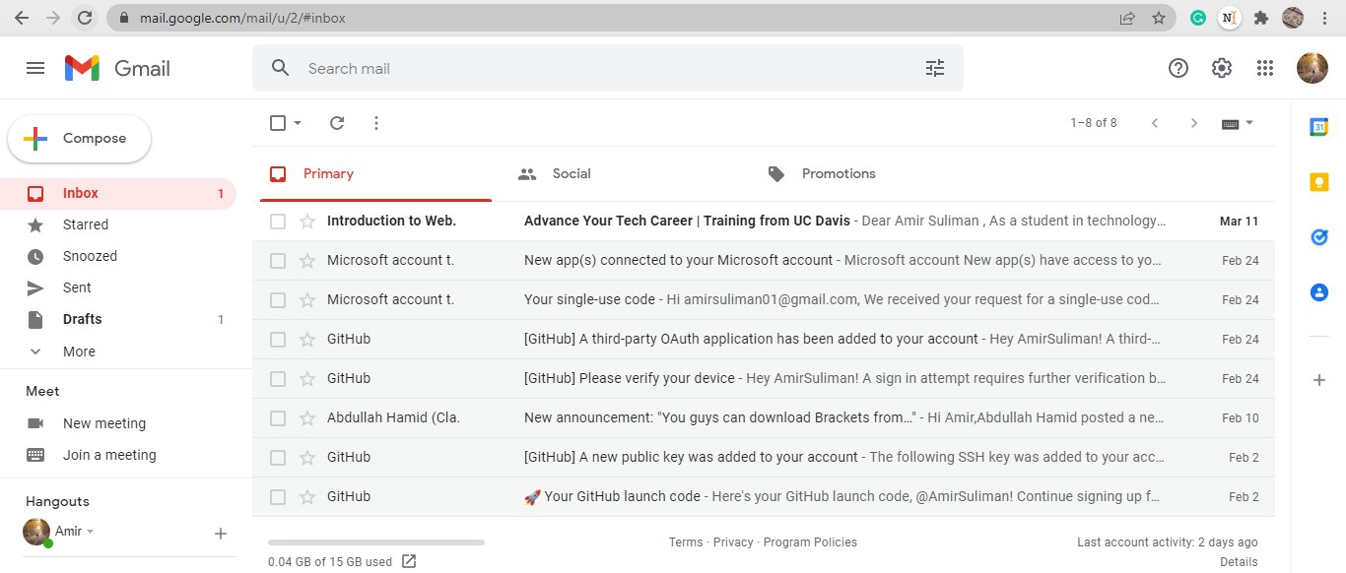

**Step2:**

Now click on compose. 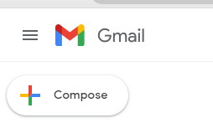

**Step3:**

Now from the file selection menu select the **insert file using drive** option.

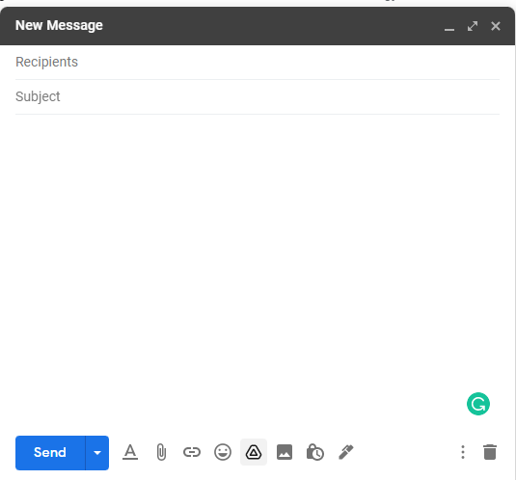

**Step4:**

As google drive opens go to the **upload** section and select or drag the file you want to send.  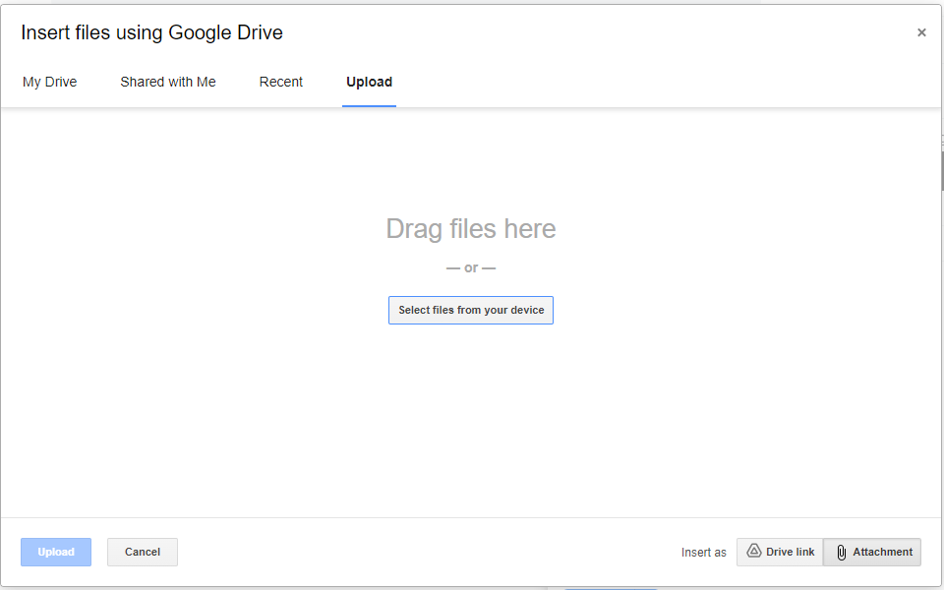

**Step5:**

Once your file is uploaded click on **send** to send the file.

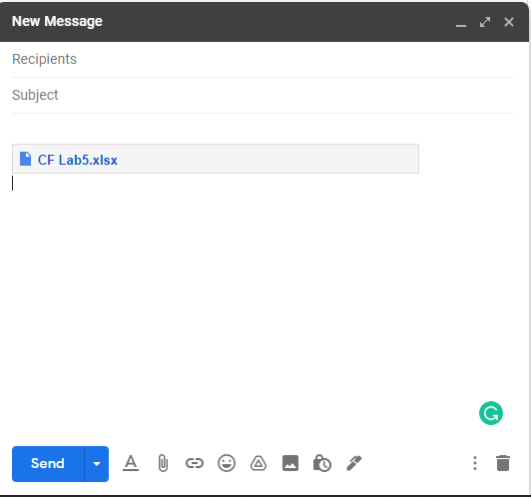

**Step6:**

As you click on **send** button it will ask you to check some options as shown in the below screenshot. Fill in that options as per your requirements.

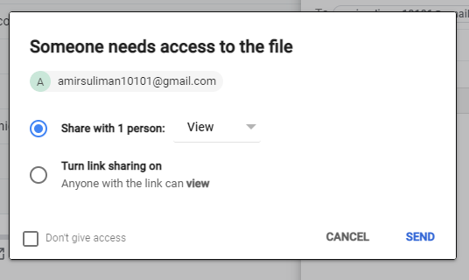

**Step7:**

Finally click on **send** button to send.